Resource Guide
CHICAGO 100K HIRING FAIR - SOUTH SIDE RESOURCES
SERVICES PROVIDED | ORGANIZATION |  |  | CONTACT NAME |  | CONTACT INFORMATION
Criminal Record: Do you have a prior arrest? Do not let it prevent you from pursuing your dreams.
Record relief + expungement | 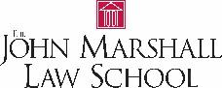 | The John Marshall Law School Pro Bono Program & Clinic |  |  |  | 312.427.2737 ext. 477 or probono@jmls.edu
Education: Interested in completing high school or receiving a college degree? Connect with these resources to get started.
School re-engagement | 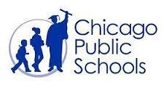 | CPS SOAR Center |  | Erinn Boone |  | eboone@cps.edu or  773-358-3248
School re-engagement |  | Kennedy-King Community College |  | Admissions |  | (773)602-5090 or  ccc.edu/kkc
Financial Support: Want to purchase a car or back to school? How you manage your money matters. Connect with this resource for helpful tips.
Financial Literacy + banking | 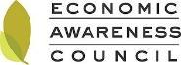 | Economic Awareness Council |  | Tracy Frizzell |  | tfrizzell@econcouncil.org
Job Readiness: There are numerous agencies on the South Side that can assist you with securing a job and remaining employed.
Jobseeker screening + professional development | 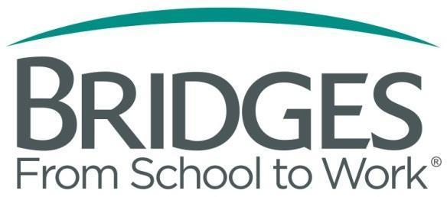 | Marriott Foundation Bridges from School to Work |  |  |  | 312-432-6240 x0
Jobseeker screening + professional development |  | Illinois Department of Employment Security |  |  |  | 773-947-2500
Jobseeker screening + professional development |  | Metropolitan Family Services |  |  |  | 773-487-3723
Jobseeker screening + professional development |  | Skills for Chicagoland’s Future |  | Daniel Torres |  | 312-906-7221
Jobseeker screening + professional development |  | Jane Addams Resource Corp |  | Rezan Kflu |  | 773-751-7112
SERVICES PROVIDED | ORGANIZATION |  |  | CONTACT NAME |  | CONTACT INFORMATION
Job Readiness: There are numerous agencies on the South Side that can assist you with securing a job and remaining employed.
Jobseeker screening + professional development |  | Asian Human Services |  | Jennifer Smith |  | 773-293-8123 or jsmith@ahschicago.org
Jobseeker screening + professional development | 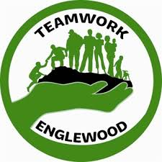 | Teamwork Englewood |  | Cherice Price |  | 312 753-9042
Jobseeker screening + professional development |  | Business and Career Services |  | Emily McMahan |  | 224-545-0765 or  emcmahan@bcsillinois.org
Jobseeker screening + professional development |  | The Chicagoland Retail Sector Center |  | Carolyne King |  | 312-281-7925 or  cking@pyramid-pci.com
Jobseeker screening + professional development |  | Employment & Employer Services Inc. | Brian Stewart |  | 773-538-5627
Jobseeker screening + professional development |  | Youth Job Center | Renetta Porte |  | 847-864-5627 ext 10

EMPLOYER INFORMATION AREA

A key to finding employment is matching companies and positions with your interests and skills. Meet with employers from various sectors including retail, food service, hospitality, and transportation distribution and logistics.

RESOURCE BLURBS

RECORD RELIEF & EXPUNGEMENT
The JMLS Pro Bono Program & Clinic provides expungement and sealing services to individuals who qualify. JMLS students review clients for eligibility and then help complete the process by obtaining and filling out the necessary documents. When necessary, students who have a 711 license can appear in court under the supervision of a license attorney. By clearing your record, you are opening the door for new job opportunities, career and higher education.

SCHOOL RE-ENGAGEMENT
SOAR Center: Are you behind in your high school credits? Do you need help catching up so you can graduate on time? Representatives from Chicago Public Schools’ Student Outreach and Re-Engagement (SOAR) Centers will be available to provide assistance with getting back into school. SOAR re-engages out-of-school and chronically truant youth and serves as a location for families seeking support to re-enroll in school. The 4 SOAR centers are integrated into community based organizations and located in neighborhoods with high populations of dropouts and with nearby Option Schools and Programs: Garfield Park (JLM Center), Little Village (Central States SER), Roseland (Phalanx Family Services) and Englewood (Salvation Army).

Kennedy-King College is dedicated to providing high-quality, comprehensive, accessible education and training opportunities that respond to changing community needs and that enable individuals to reach their full potential and successfully compete in the global marketplace. Kennedy-King College is committed to improving student learning in all programs and services through an ongoing comprehensive assessment process.

FINANCIAL LITERACY & BANKING
Do you need help opening up a bank account? Could you use advice on making better decisions with your money? Representatives from Economic Awareness Council will be available to provide information about financial literacy and related services.

JOBSEEKER SCREENING + PROFESSIONAL DEVELOPMENT

Marriott Foundation “Bridges…from school to work” is a transition program established in 1989 by the Marriott Foundation for People with Disabilities (aka The Marriott Foundation) to foster the employment success of young people with disabilities. The program develops opportunities for work and vocational development for young people with disabilities as they leave high school.

The Illinois Department of Employment Security Hire the Future program is for youth ages 16-24. The program provides services to increase employability, assist youth in making informed career decisions, and assist youth in building skills and positive work habits.

The Financial Opportunity Center (FOC) at Metropolitan Family Services provides career and personal financial services that help low- to moderate-income people build smart money habits and focus on the financial bottom line. Our FOC provides employment and career counseling, one-on-one financial coaching and education and low-cost financial products that help build credit, savings and assets. We also connect clients with income supports such as food stamps, utilities assistance and affordable health insurance. The cornerstone of the FOC model is providing these services in an integrated way—rather than as stand-alone services—and with a long-term commitment to helping clients reach their goals.

Skills for Chicagoland's Future (Skills) is a nonprofit organization that partners with companies across the Chicagoland area to place unemployed and underemployed job seekers into jobs at no cost. These employers are committed to hiring talent through Skills. Job seekers who apply for positions gain the opportunity to either directly apply to a role or create a general profile for consideration by Skills’ recruiters. In addition, job seekers receive personal guidance through the application process and constructive advice that will increase the chance of getting hired. Skills is your connection to employment with over 50 top companies across all major industries including: BMO Harris Bank, CDW, Chase Bank, Divvy, Gap Inc., Jewel-Osco, Rush University Medical Center, University of Chicago Medicine, Ulta Beauty, United Airlines, Walgreens, Yelp, and more!

Jane Addams Resource Corporation
“I’m not sure what I want to do after high school.”
“I can’t afford to go to college.”
“How do I go to school when I have a family to support?”
“I want a stable career with benefits, not just a job.”
“I don’t have the time to go back to school and work.”
“Not your typical girl. Not afraid to get my hands dirty. Like the idea of being able to fix and build things yourself?”
“Want a hot career?”

Consider the Careers in Manufacturing Program at Jane Addams Resource Corporation. Two locations on the north and west side. Morning and evening hours. Hands on training and job placement assistance afterward.

Asian Human Services assists 18-24 year old out of school youth with ITA trainings, job readiness, and employment services. The biggest trainings we have are CNA/PCT Trainings and Food Services Trainings. We assist individuals with employment services such as resume building, interviewing skills and on the job trainings. We are located in Uptown off the Lawrence Stop and are currently enrolling.

Teamwork Englewood offers a comprehensive workforce development program which is centered around job readiness, career development and placement into various employment opportunities. Through our Re-entry, Starbucks Customer Service Training and general employment seeking programs, we provide a structured, and hands-on approach to job development for our many program participants.

Business and Career Services, Inc. (BCS) holds a contract with the Chicago Cook Workforce Partnership to operate the Illinois workNet Center in Arlington Heights, IL and its affiliate sites in Robbins and Hanover Park. BCS runs the Manufacturing Careers Internship Program (MCIP) enabling eligible youth ages 18 to 24 an opportunity to find a meaningful and productive career in manufacturing through unique boot camp and paid internship model. Business and Career Services, Inc, is a proud partner of the American Job Center network.

The Chicagoland Retail Sector Center is funded through a 10.9 million grant the Walmart Foundation made to the Chicago Cook Workforce Partnership. Its goal is to increase the economic mobility of workers in retail and related sectors. The Retail Sector provides free workforce solutions for employers and job seekers including skills assessments, retail credentialing, specialized hiring events, customized training, and connecting employers to qualified pre-screened candidates.
Employment and Employer Services has worked to strengthen the connection between job seekers, employers, and government so that Chicago continues to flourish as The City That Works, since 1982. During this time, we have helped over 60,000 people find good jobs with more than 3,000 Chicagoland employers.

Youth Job Center provides job referral, placement, and retention services to youth ages 14-25, as well as Career Pathways programs for young adults ages 18-25.

